Hybrid security system using license plate and voice recognition technology

Abrar Islam (160021017)

Abdullah Al Mehadi (160021025)

**Abstract--- License plate recognition is a well-recognized technology. On the other hand voice recognition is already very popular system and used for safety issues which makes the application easier to use. These two are combined to create a sophisticated system. To get higher accuracy, machine learning was used to tackle large amount of data. In voice recognition, neural network algorithm as well as non-machine learning approach was used. Hence a comparison of two system as well as benefits of integrating two system was studied. This observation will prove the significance of machine learning algorithm**.

**Introduction**

Automatic number-plate recognition is a technology that uses [optical character recognition](https://en.wikipedia.org/wiki/Optical_character_recognition) on images to read [vehicle registration plates](https://en.wikipedia.org/wiki/Vehicle_registration_plate) to create [vehicle location data](https://en.wikipedia.org/wiki/Vehicle_location_data). It can use existing [closed-circuit television](https://en.wikipedia.org/wiki/Closed-circuit_television), [road-rule enforcement cameras](https://en.wikipedia.org/wiki/Road-rule_enforcement_camera), or cameras specifically designed for the task. ANPR is used by police forces around the world for law enforcement purposes, including to check if a [vehicle is registered](https://en.wikipedia.org/wiki/Vehicle_registration) or [licensed](https://en.wikipedia.org/wiki/Vehicle_licence). It is also used for [electronic toll collection](https://en.wikipedia.org/wiki/Electronic_toll_collection) on [pay-per-use roads](https://en.wikipedia.org/wiki/Road_pricing) and as a method of cataloguing the movements of traffic, for example by highways agencies.

Automatic number-plate recognition can be used to store the images captured by the cameras as well as the text from the license plate, with some configurable to store a photograph of the driver. Systems commonly use [infrared](https://en.wikipedia.org/wiki/Infrared) lighting to allow the camera to take the picture at any time of day or night. ANPR technology must take into account plate variations from place to place. Privacy issues have caused concerns about ANPR, such as government tracking citizens' movements, misidentification, high error rates, and increased government spending. Critics have described it as a form of [mass surveillance](https://en.wikipedia.org/wiki/Mass_surveillance).

Voice recognition is a computer software program or hardware device with the ability to decode the human voice. Voice recognition is commonly used to operate a device, perform commands, or write without having to use a keyboard, mouse, or press any buttons. Today, this is done on a computer with ASR (automatic speech recognition) software programs. Many ASR programs require the user to "train" the ASR program to recognize their voice so that it can more accurately convert the speech to text.

We have come up with a sophisticated system that integrates both of these features to level up the security protection that can be implemented using machine learning.

Data is the lifeblood of all business. Data-driven decisions increasingly make the difference between keeping up with competition or falling further behind. Machine learning can be the key to unlocking the value of data and enacting decisions. Machines learn and provide intelligent insights through a sophisticated use of [learning algorithms](https://mapr.com/blog/mapr-and-machine-learning-polytheism/#training-algorithms). To provide business value, the machine is trained to learn patterns from data and then can proceed autonomously on new and changing data. This creates a dynamic feedback loop, which allows it to efficiently generate more models to gain further insights, even more accurately, without requiring additional resources or human interaction. With continuous advancement in this field, machines are becoming increasingly self-healing, self-organizing, and self-architecting, seamlessly producing greater value.

Resurging interest in machine learning is due to the same factors that have made [data mining](https://www.sas.com/en_us/insights/analytics/data-mining.html) and Bayesian analysis more popular than ever. Things like growing volumes and varieties of available data, computational processing that is cheaper and more powerful, and affordable data storage. Data preparation capabilities , basic and advanced algorithms, automation and iterative processes, scalability, ensemble modeling these are required for good machine learning system.

**Methodology**

For the license plate recognition part, simple correlation was used to compare the input image with the trained image. Here no machine learning algorithm was used.

In the voice recognition part, there was two-way approach. From one end, without machine learning, from other end with machine learning.

1. License Plate Recognition

In this part, there was no use of machine learning algorithm. The whole algorithm for this code could be divided in three parts -

*i) Template creation* : In this portion of code, the binary images of all the alphabets and numbers were stored in different variables.

*ii) Number plate detection :* This piece of code extracted the number plate portion of the car, from the whole image. But at first, RGB input image had to be converted into gray-scale image to reduce the usage of memory. Also there was

the use of edge detector that helped to extract the plate portion.

*iii) Letter detection :* Finally, from the extracted portion of the plate, which was got from the previous section, this code tried to separated the letters, and compare each of the letters with the previously built template. This comparison was made with the help of correlation. “corr2” function was used, and which comparison gave the maximum value, that was considered as the detected letter.

In **fig.1** there are the different states of the images, beginning from input RGB image, to license plate extraction. The flow chart of the whole process is showed in **fig.2.**

1. Voice Recognition

This part was used as an alternative way to input image for license plate recognition part. The purpose of this part is to recognize the voice as the user saying from 0-9 digit. Two different approaches were made in this portion. One was without machine learning algorithm, another one was with machine learning algorithm. As a result, the difference in the performance between two cases could be observed closely here.

*i) Without machine learning :* This approach was almost similar to the steps that were followed in license plate recognition. The main difference is, in the previous case “corr2” MATLAB function was used for comparison. Here, “autocorr” function was used for this purpose. The rest was same.

*ii) With machine learning :* Neural Network algorithm was used in this approach. There were several steps that were performed for getting the expected result. **Fig.3** represents the flowchart of the whole process –

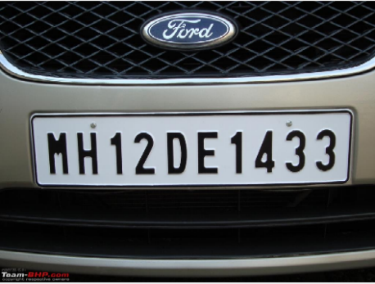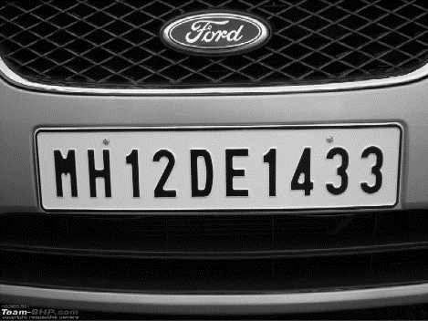

b

a

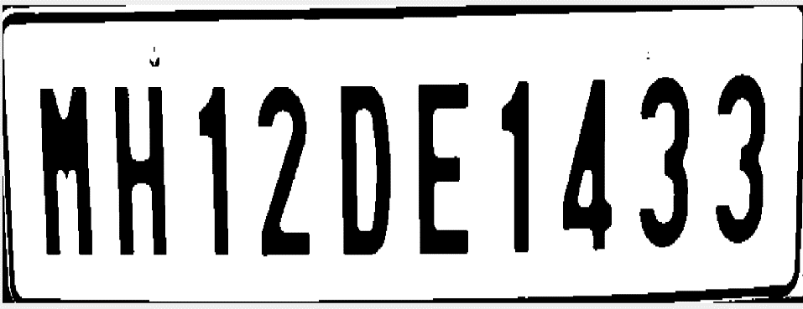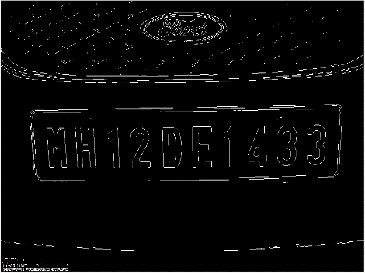

e

d

**Fig.1**- different state of the images (a) input image (b) after converting to gray-scale (c) after binarized (d) after applying edged detection (e) after extracting the plate portion

|  |  |
| --- | --- |
| **Learning Rate** | **Test Accuracy** |
| 1.5 | 65% |
| 0.5 | 89% |
| 0.1 | 94% |
| 0.05 | 97% |
| 0.01 | 98% |

**Table-1**

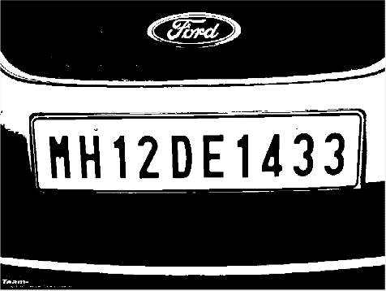

c

a. Creating the data : Normally in machine learning, the more data you have, the more advantage you get. Though there are some exceptions. But here exception was not the case. So 800 data was created by recording through MATLAB.

b. Data synthesizing : It was used to increase training examples upto 1600.

c. Feature extraction : After creating the data, it’s important to choose appropriate feature. Here autocorrelation was chose as the feature. The sampling frequency of the recorded data was 8000 kHz. After applying auto correlation, for each example, 21 features were created. Among them, the first one was left behind, as for every example it was same(1).

d. Choosing the parameters : There were some parameters that needed to be determined, like the leaning rate alpha, number of hidden layers, number of iterations and the value of epsilon, which was used to initialize ‘theta’. By calculating the test set accuracy for different numbers, the best possible combination of numbers were taken. Choosing the learning rate accordingly is a very important task. At first different values of alpha were taken and then test accuracy were calculated for each of them. Among them best accuracy given alpha was 0.01(**table1**). This choice were cross checked by running an cost function vs No. of iteration graph(**fig.4**). It can be observed that for alpha 1.5, there is oscillation for cost function, meaning minimum cost not be achieved here. Among other alpha values, for 0.5 the cost function converges quickly. But, in the zoom figure(**fig.4(b)**) it was observed that other than the 0.01 value, other alpha values oscillate a little around 250-500 iteration region. So no wonder for 0.01 value, the highest accuracy was achieved.

Other unknown parameters were determined with a same approach.

e. Training the dataset : After determining the value of the parameters, the algorithm was trained and the final value of ‘theta’ was calculated and stored.

f. Prediction : This is the prediction portion. In this part new record was taken as input. With the stored value of ‘theta’ parameter, this prediction portion tried to predict the outcome .

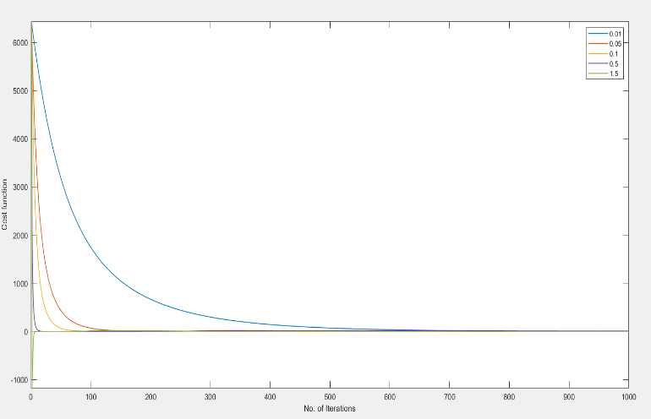

(a)

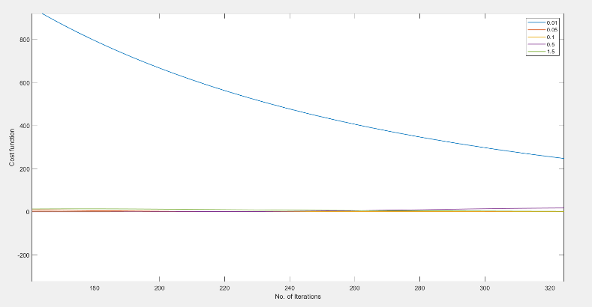

(b)

**Fig.4** – cost function vs number of iterations graph for different alpha (a) normal scale (b) zoom view, focusing on the oscillation part

**Results and Discussions**

All of the methods that were discussed, were combined in a GUI platform(**fig.5**).

*i) License plate recognition* : From the extracted plate portion, by comparing each letter, in the “Plate No” box, the predicted numbers of the plate was showed,**fig.5**.

*ii) Voice recognition :* There is an extra feature for voice recognition. By using the pushbutton “Speak”, user can input image by saying the number of the particular image through microphone, **fig.5**.

Another purpose of this project was to compare the performance between non-machine learning approach and machine learning approach. The license plate recognition part and one part of voice recognition was done by non-machine learning approach. Another part of voice recognition part was done by machine learning, neural network algorithm. The performance was determined through test accuracy. As we can see from **table2** the test accuracy for non-machine learning approach was lower than the machine learning approach. Machine learning approach has a pretty high accuracy. That is because, neural network algorithm has the ability to reduce its error over iteration(fig.5) through back propagation. So the more example, the more iteration, the more accuracy can be achieved. In this project, there were 1600 examples and 15000 iterations were done finally. And from that the accuracy that was achieved : 98%.

|  |  |  |
| --- | --- | --- |
|  |  | **Accuracy** |
| Non - ML | License plate recognition | 87% |
| Non - ML | Voice recognition | 83% |
| ML(NN) | Voice recognition | 98% |

**Table-2**

That is why machine learning is such a famous and efficient process. And the algorithm, neural network is also famous in this era, as neural network’s performance depends on mainly number of examples. In this era of internet, it is pretty easy to gather a huge amount of data in a short period of time.

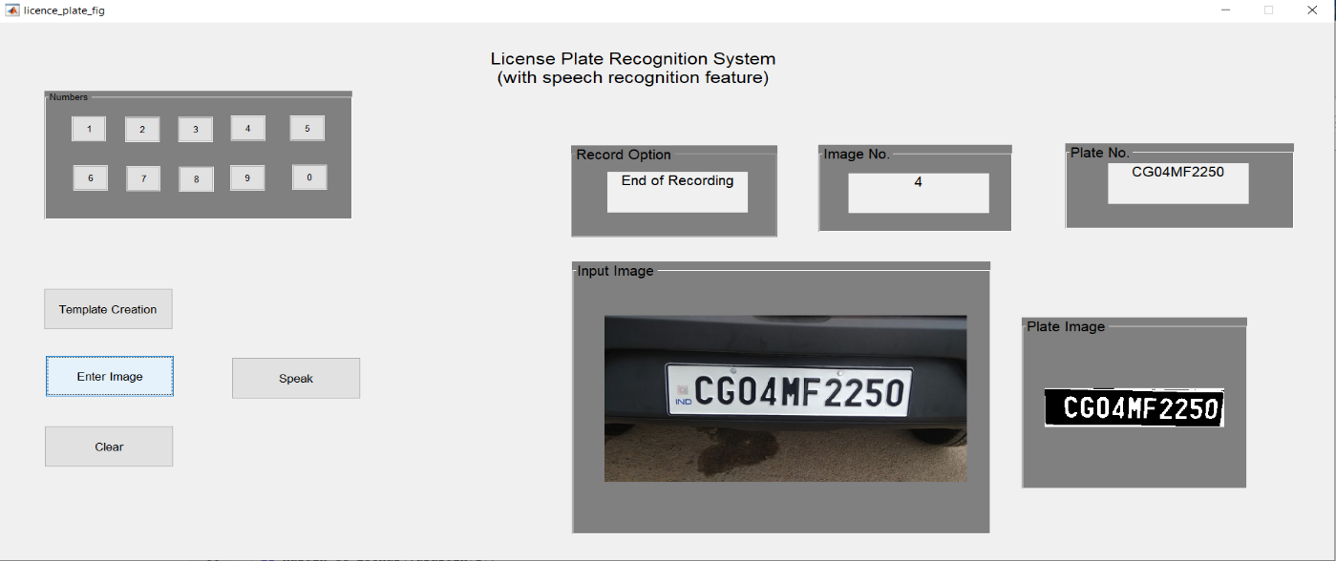

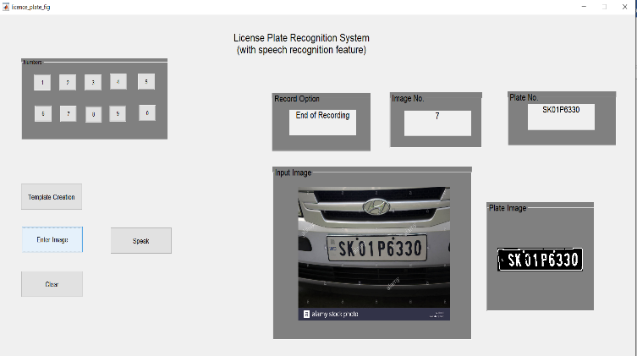

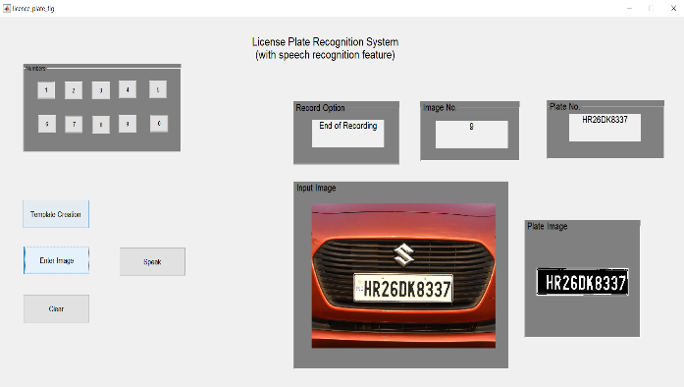

**Fig.5**- The GUI platform with result

**Conclusion:**

Thus, from our system it is apparent that the hybrid number plate and voice recognition software provides substantial benefit to the user in the form of added security and protection. Thus, there will be less case of theft and robbery. At the same time, if we manage to install close circuit cameras at every corner of the road, we will be able to keep track of our car at any moment. For this system to get full advantage we need global monitoring system as well as sophisticated technology at the same time. In-future this type of double security system possess great potential in our society.